**Sonar-scanner Installation:**

Sonar scanner is used to scan the code and push it to the sonar dashboard. We no need to install this separately if we use sonar-scanner plugin in Jenkins or azure devops.

We can download the sonar-scanner zip file to windows or Linux machines and unzip it

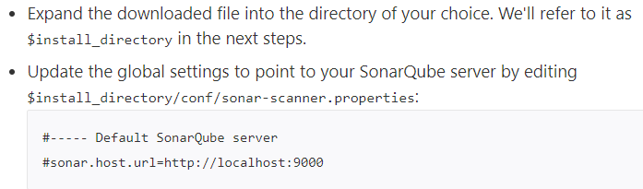

We can also add all the project related properties to this file and then execute the “sonar-scanner” in bin directory

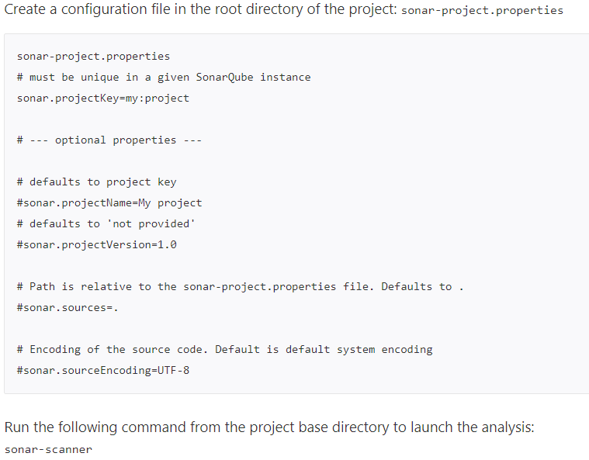

Or we can add this sonar-scanner bin directory to the bash profile. So that we can access it from anywhere



**Alternatives of sonar scanner properties file:**

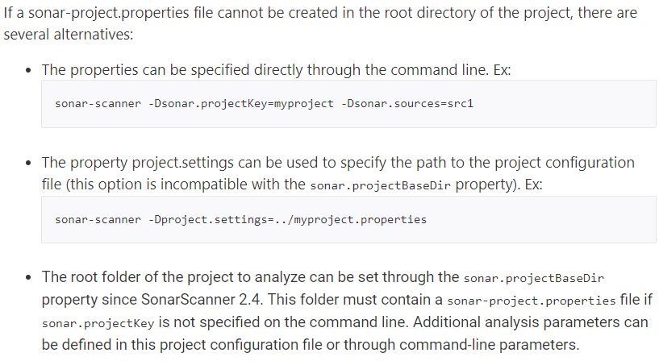

**Alternate analysis directory:**

